Name: RITESH KUMAR  Mob. No. 9768804941  Email Id: ritesh.srm89@gmail.com
  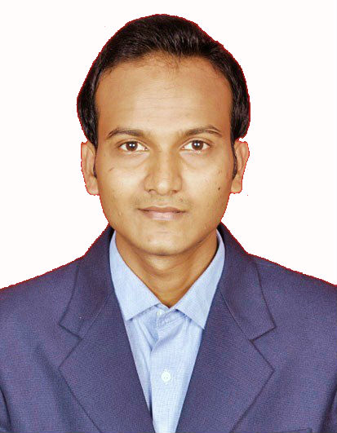

Career Objective: To integrate my academic learning with the practical demands of the profession and in the process, mutually grow and succeed personally along with the organization. I would like to grow with one institution, contribute to it and finally rise to its decision making and strategy formulating levels

Summer Internship Project details

Company : ITC LIMITED
Location : MUMBAI
Duration : 3 Months
Project Title : Comparative analysis of Farmlite and Nutrichoice

Educational Qualifications:

Degree | School / College Name | Board / University | Year of Passing | % / CGPA
PGPM  [MARKETING] | ICFAI BUSINESS SCHOOL | ICFAI UNIVERSITY | 2015 | 7.27
Graduation  [ B.Tech - Biotechnology] | SRM | SRM UNIVERSITY | 2011 | 7.209
H.S.C. | B.D.EVENING COLLEGE | B.I.E.C (STATE BOARD) | 2006 | 52.50
S.S.C. | St.JOSEPH PUBLIC SCHOOL | C.B.S.E | 2004 | 58.40

Computer Skills:

- Language: C, MS Office
- Operating System: Windows, xp

Other Projects Undertaken:

Mycobased biosynthesis of silver nanoparticles and studies of its synergistic antibacterial activity combined with cefazolin antibiotic against selected organism
- Wal-Mart a customer centric Approach
- Application of information technology in automobile industry for maintaining CRM
- Project on Consumer Buying Decision on soft drinks in BRM

Work Experience:

Name of Company | Designation | Job Profile | Work Exp in Months
IDS INFOTECH LTD | I&A Associate | Analyzing the research article and enhancing its searcheability for researchers | 17

Achievements

- Had an INTERNATIONAL PUBLICATION in AUSTRALIAN JOURNAL OF BASIC AND APPLIED SCIENCE in August 2011.

Extra-curricular activities

- Committee member in “HYBRIDOMIA” at National level Techfest organized by SRM University, Chennai.
- Member of FORES and MARKOPHILIA a club house in IBS MUMBAI
- House captain of “Sports in University”

Hobbies / Interests
- Listening Music
- Cricket

Personal Details:

Date of Birth | :
14-11-1989

Languages known
English,Hindi
Current Address
Flat No - 304, B-Wing, Arogaya Sadan, Bapujuvekar marg, Bhandup (East), Mumbai-400042

Permanent Address
M.I.Lane, Naya Tola, Saristabad, Gardanibagh, Patna (BIHAR)-800001

